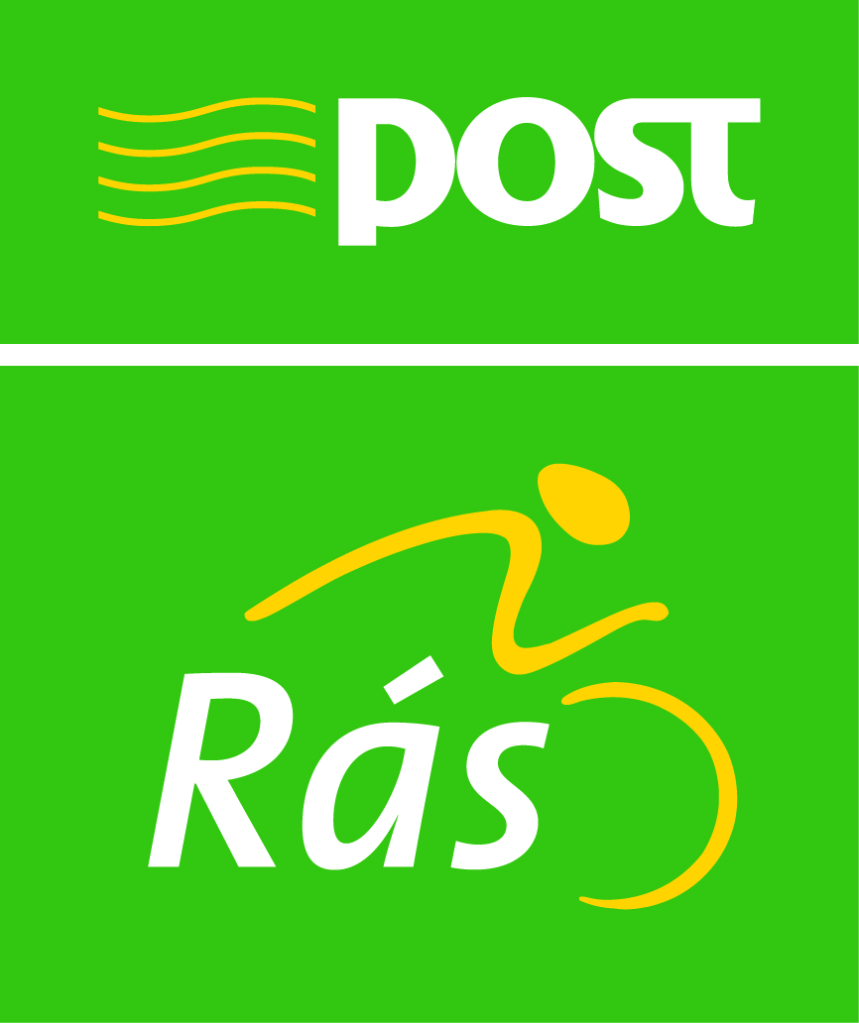
8 Day International Cycle Race

22nd – 29th May 2011

Sponsored An Post

Stage End Accommodation Officers

Portumna Kilrush
Mrs. Mary Lynch, Ann Young,
Oak Lodge B & B, Fort Road.,
St. Brendan’s Road, Kilrush,
Portumna, Co. Clare.
Co. Galway. Mobile : 087 - 9047787
Telephone : 0909-741549 E-mail:annyounghector@yahoo.ie
Mobile: 087 - 7924161

Castleisland Castletownbere
Mark Collins, Miah O’Sullivan,
Lisheenbawn, Suchsia Lodge,
Farranfore, Filane,
Co. Kerry. Castletownbere.
Telephone: 086 - 8579354 Co. Cork.
E-mail: mark.collins.1@hotmail.com Mobile: 086 - 8372983
Email: jaosullivan@eircom.net

Blarney Tramore
Martin O’Shea, Avery Coryell,

1 Muskerry Terrace, Beach Haven House,

Blarney, Tivoli Terrace,

Co. Cork. Tramore,
Telephone: 021 - 70386 Co. Waterford.
Mobile : 086 - 4099907 Telephone: 051 - 390208
E-mail:osheablarney@hotmail.com E-mail: beachhavenhouse.com

Kildare Skerries
John Malone, Edward Dawson,
5 Lindon Court, 3 Maple Lawn,
Portlaoise , Ballon,
Co. Laois. Co. Carlow
Mobile 087 - 2453403 Mobile 087 – 2523958
E-mail: johnmalone817@yahoo.co.uk E-mail: eddiedawson@anpostras.com

_______________________________________________________________
Sponsored By An Post

